3 exercises for building self esteem

- Keep a happy list

The following exercise is incredibly powerful. It involves keeping a top 10 list of happy thoughts and keeping a record of them. I'd then encourage you to spend a few minutes 3 times a day looking over the list again and again. Allow the list to grow by adding new ones to the bottom of the list, it's lovely to remember that special cuddle or card someone wrote you days later that you might have otherwise forgotten. It really helps your mood to process and remember the good things in your life.

Fill in the table with 10 things that have happened recently, they can be really simple, the momentum and change comes as you keep this up every day adding one or two and as you take the time to read them. Watch and feel as your outlook and posture changes. When you've finished writing them, really think and feel a great sense of achievement.

Positive situation | What made this experience positive? | What I'd say to my best friend if they experienced this event | What I'm thankful for and what I've learnt
I managed to meet a friend today even though I was feeling down | It was really nice to get out | Well down for overcoming! | I feel better when I spend time with friends

2) Give yourself margin

We all live very busy and hectic lives but this can come at the cost of your well-being. When you slow down a little and allow yourself to enjoy the moment and de stress it has a very positive impact on wellbeing. When you are incredibly busy and stretched your body begins to pump out your stress hormones all the time, this can make you feel more anxious and on edge even when you are trying to relax or go to sleep.

To try and counter this try and manage your diary better! Give your self-margin and space to reflect and enjoy yourself. Get in the habit of saying no to things you don't actually want to do, or put off things so that your diary isn’t overloaded. Operate out of a place of rest rather than exhaustion. Your body will begin to produce less stress hormones as you slow down and this can have a positive impact on well being.

Don't overload your day. To help you look at your week pictorially follow this simple exercise:

Colour code your diary;

Red is something you thing exhausting, unenjoyable or energy draining. You should have a max of 1 a day, and if your suffering severe anxiety and / or depression 1-2 a week e.g.) seeing a person or family member you find especially difficult, large social events, meeting new people or even going to work . Red activities will be different for everyone. What is exhausting for me may be a green activity for you and visa versus.

My red activities:

Orange is a neutral activity, something you neither especially enjoy nor dislike. They are energy neutral e.g. doing the washing up, tidying the house, doing admin.

My orange activities:

Green activities are energy restoring, they are fun, enjoyable and restorative. They will be completely different depending on whether you are an introvert or extrovert, examples may include; meeting a friend for coffee, going to the gym, reading a book, talking to a friend on the phone or listening to music

My green activities:

Complete the sample diary for your past 7 days. Write in your schedule and colour code each section. At the end of the week reflect on the overwhelming colour. If it's mainly red and orange it's possible a sign your week is too busy and this may be impacting your wellbeing.

My past 7 days

 | Morning | Afternoon | Evening | Night | How I felt
Monday
Tuesday
Wednesday
Thursday
Friday
Saturday
Sunday

How I felt at the end of the week:

My next 7 days

Rules: only 1 red per day maximum (unless it's work or other essential activities like caring for children!), at least 1 green activity a day

 | Morning | Afternoon | Evening | Night | How I felt
Monday
Tuesday
Wednesday
Thursday
Friday
Saturday
Sunday

How I felt at the end of the week:

Week 2:

Redo the same exercise but work really hard to limit the red activities and introduce more green.

 | Morning | Afternoon | Evening | Night | How I felt
Monday
Tuesday
Wednesday
Thursday
Friday
Saturday
Sunday

3) Be kind to yourself

Part of building your self esteem is teaching your inner voice to be your best friend, to build you up and to encourage you.

Spend 5 minutes every day (it can be while you’re in the shower or driving to work) being as kind to yourself as you would a good friend. For example, if something goes wrong don't speak negatively over yourself but find the positive (there is always something) and chose to believe that. Encourage yourself in the same way you would someone you really care about.

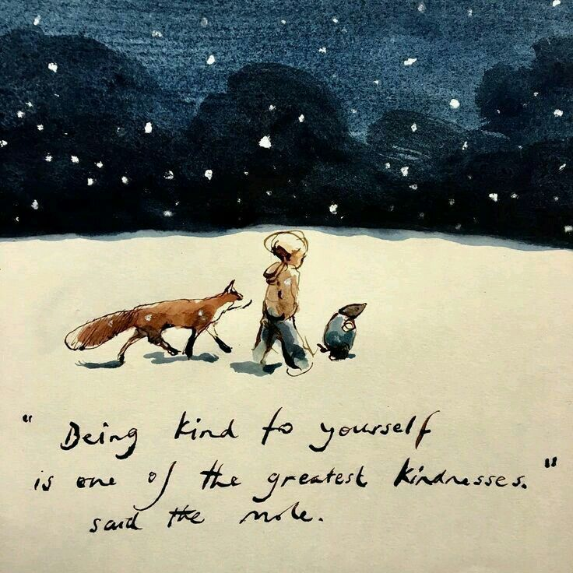

Charlie Mackesy the boy the mole the fox and the horse

